**Unit 10 Circles Exam**

*28 points*

**Part 1 – Multiple Choice. Answer all questions.** *(4 points)*

1. *(1 point)*  
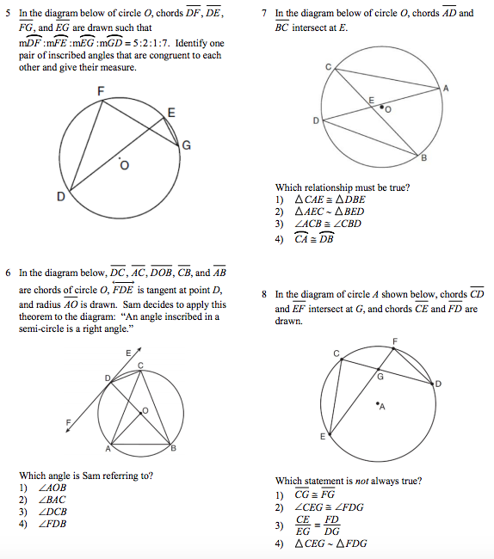

3. *(1 point)*****

2. *(1 point)*  


4. *(1 point)*  
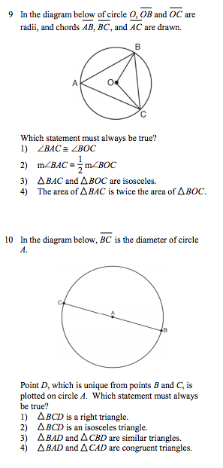

**Part 2 – Pick 2 out of 3 questions to answer.** *(4 points)*

1. *(2 points)*
2. 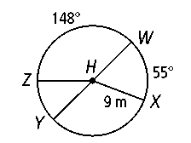**What is the measure of arc XY?**
3. **What is the measure of arc YWX?**
4. **Find the length of arc BC in terms of .** *(2 points)*

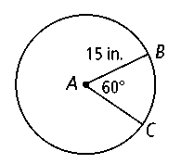

1. 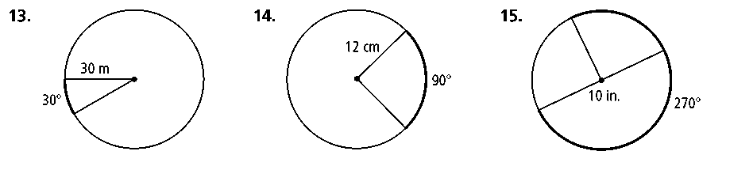**Find the area of the sector bound by the minor arc in terms of ..** *(2 points)*

**Part 3 – Pick 2 out of 3 questions to answer.** *(4 points)*

1. *(2 points)*  
   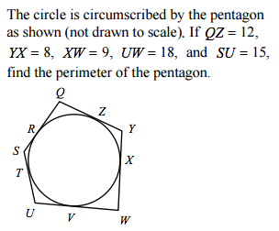
2. *(2 points)*  
   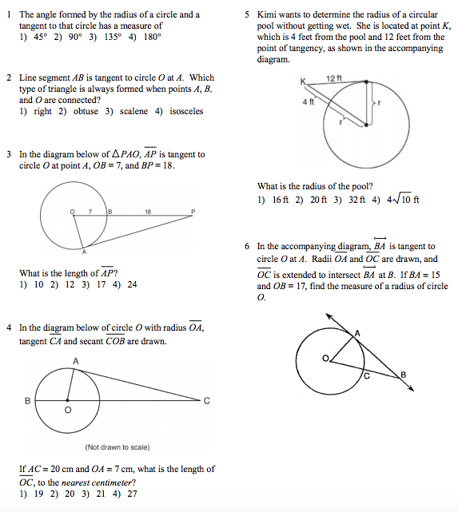
3. *(2 points)*  
   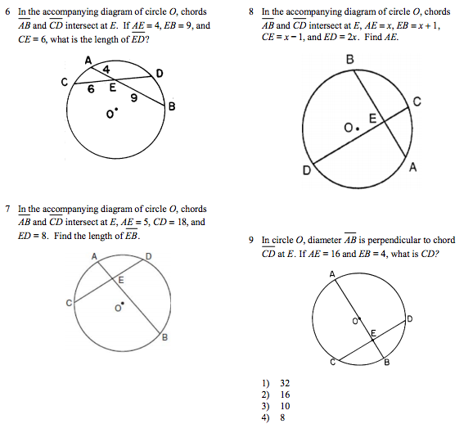

**Part 4 – Pick 3 out of 4 questions to answer.** *(6 points)*

**7.** *(2 points)*   
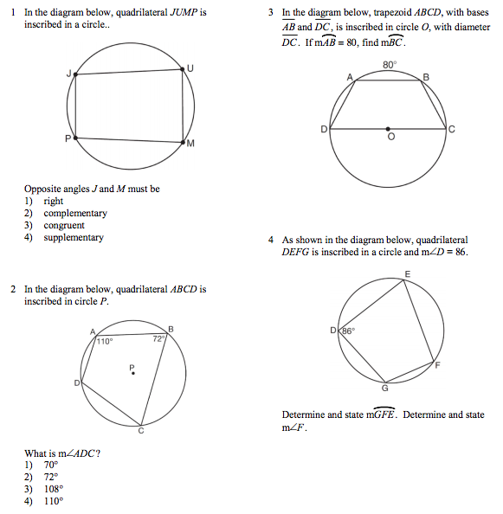

**9.** *(2 points)*  
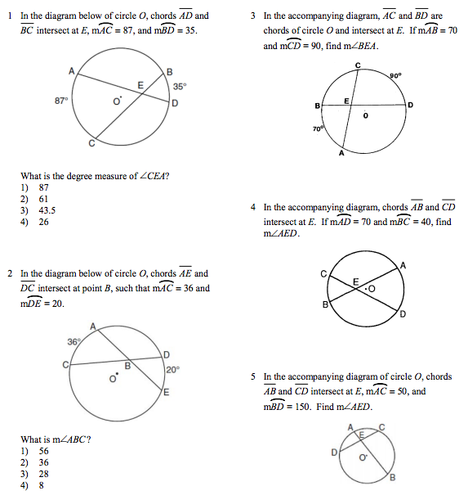

**8.** *(2 points)*  
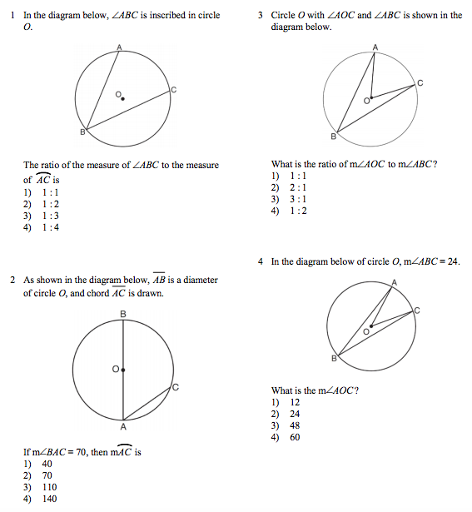

**10.** *(2 points)*  
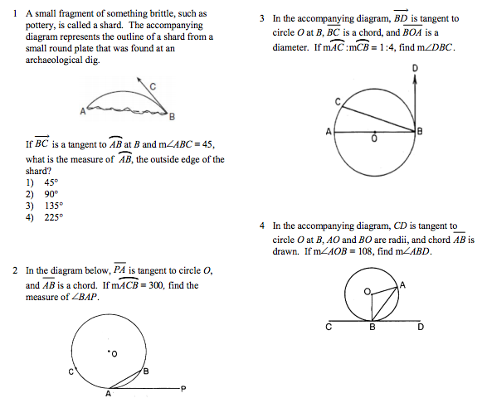

**Part 5 – Pick 3 out of 4 questions to answer.** *(6 points)*

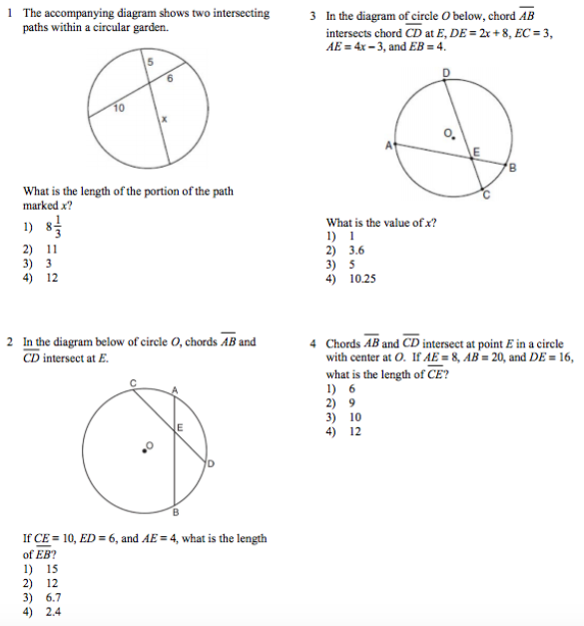**11.** *(2 points)* **12.** *(2 points)*  
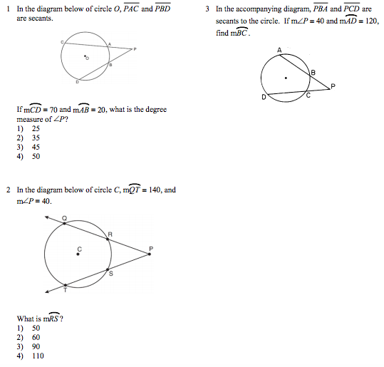

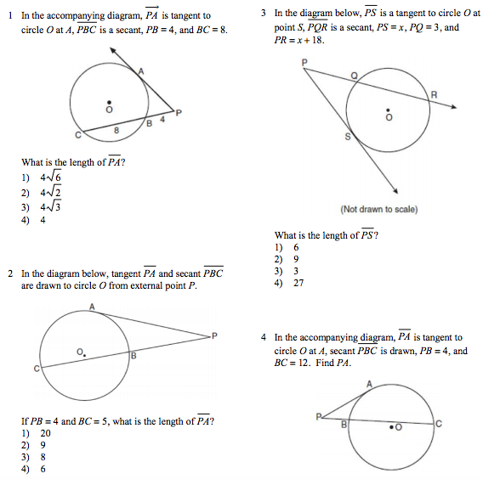**13.** *(2 points)* **14.** *(2 points)*  
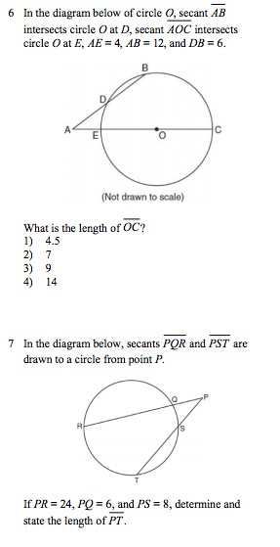

**Part 6 – Answer both questions.** *(4 points)*

**15.** *(2 points)*  
The standard equation of a circle is given below. Identify the center and the radius of the circle.

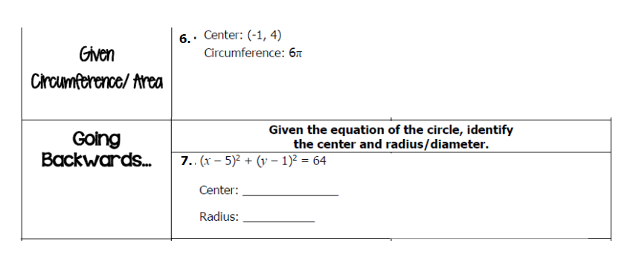

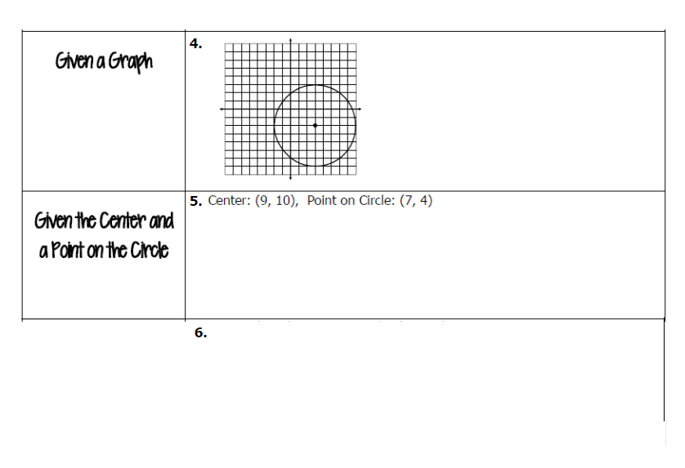**16.** *(2 points)*  
Write the standard equation of the circle graphed below with center at (3, - 2) given point on the circle at (- 2, - 2).

**Extra Credit:**

1. *(+2 points)* 2. *(+2 points)*

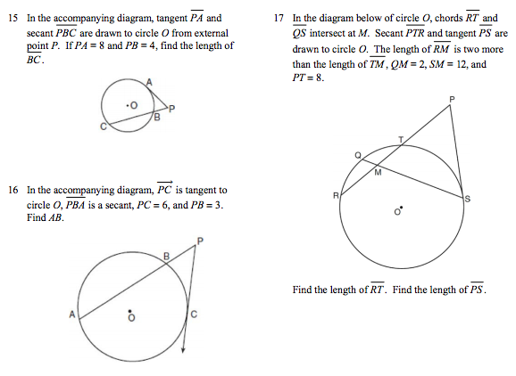

http://www.softschools.com/math/calculus/images/completing_the_square_circles_img_26.pngFind the center and radius of the circle whose equation is given below.